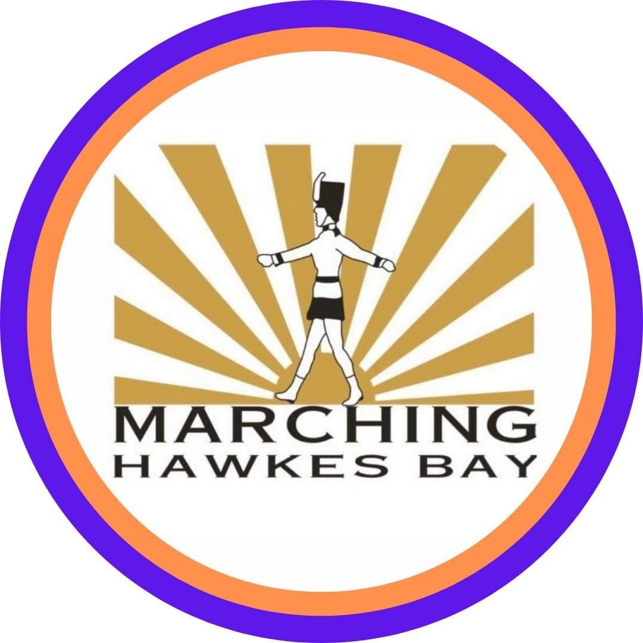

**NORTH ISLAND CHAMPIONSHIPS  
Hawke’s Bay 14th December 2024  
Pettigrew Green Arena, Napier**

**UNDER 13 GRADE**

🥇 1st Technical – Glennette – Wellington  
 Coaches – Michelle & Aimee Burton

🥈 2nd Technical – Buckingham Guards – Hawke’s Bay  
 Coaches – Stacey Sime & Shonna Forrest-Davy

🥉 3rd Technical – Silverdettes – Waikato  
 Coaches – Lara Porter & Taylor Voeroes

🥇 1st Display - Buckingham Guards – Hawke’s Bay  
 Coaches – Stacey Sime & Shonna Forrest-Davy

🥈 2nd Display – Glennette – Wellington  
 Coaches – Michelle & Aimee Burton

🥉 3rd Display – Silverdettes – Waikato  
 Coaches – Lara Porter & Taylor Voeroes

🏆 CHAMPION UNDER 13 GRADE TEAM – Glennette - Wellington  
 Coaches – Michelle & Aimee Burton

**UNDER 18 GRADE**

🥇 1st Technical – Buckingham Guards – Hawke’s Bay  
 Coaches – Stacey & Chelsea Sime

🥈 2nd Technical – Glennette - Wellington  
 Coaches – Cheryl Lovett & Michelle Burton

🥉 3rd Technical – Ruawai - Waikato  
 Coaches – Victoria Hastings & Dayna Holloway

🥇 1st Display - Glennette - Wellington  
 Coaches – Cheryl Lovett & Michelle Burton

🥈 2nd Display – Buckingham Guards – Hawke’s Bay  
 Coaches – Stacey & Chelsea Sime

🥉 3rd Display - Ruawai - Waikato  
 Coaches – Victoria Hastings & Dayna Holloway

🏆 CHAMPION UNDER 18 - GRADE TEAM – Buckingham Guards – Hawke’s Bay  
 Coaches – Stacey & Chelsea Sime



**MASTERS GRADE**

🥇 1st Technical – Bandolier - Wellington  
 Coach - Wendy Lappin

🥇 1st Display – Madison Blues - Waikato  
 Coaches – Karen Bedingfield & Tamara Hayward

🏆 CHAMPION MASTERS GRADE TEAM – Bandolier - Wellington  
 Coach – Wendy Lappin

**SENIOR GRADE**

🥇 1st Technical – SWIS - Wellington  
 Coach – Ema Wihapi-Solia

🥈 2nd Technical – Misfits - Taranaki   
 Coach – Rebecca Haupapa

🥇 1st Display - SWIS - Wellington  
 Coach – Ema Wihapi-Solia

🥈 2nd Display – Glennette - Wellington  
 Coaches – Cheryl Lovett & Michelle Burton

🏆 CHAMPION SENIOR GRADE TEAM – SWIS - Wellington  
 Coach – Ema Wihapi-Solia